You are receiving this email as a member of the media.
If you wish to unsubscribe from future messages, please reply with UNSUBSCRIBE in the subject line.

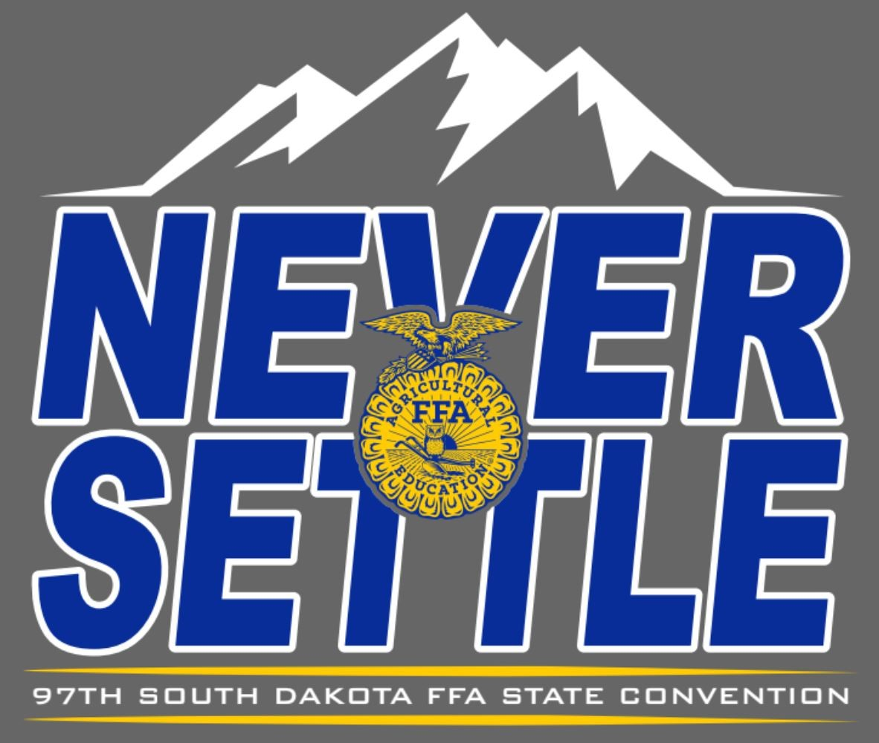
NEWS RELEASE

South Dakota FFA Association

Website: www.sdaged.org
Facebook: www.facebook.com/South.Dakota.FFA
Instagram: @sdffaassociation
For more information, contact:
Caroline Hansen
South Dakota Leadership and Program Manager
Caroline.hansen@sdaged.org

FOR IMMEDIATE RELEASE
April 8, 2025

Photos of top 3 individuals in each area are available to download at: https://drive.google.com/drive/folders/1_04VSp9-1PP77VYzXL79cKT7qn3wyORv
South Dakota FFA Proficiency Winners Recognized
BROOKINGS, S.D. – South Dakota FFA members were recognized at the 97th South Dakota State FFA Convention for excellence in developing career-specific skills through their Supervised Agricultural Experience (SAE) Proficiency projects.
The FFA Agricultural Proficiency Awards recognize members who have developed their skills and abilities related to employment, internships, apprenticeships and their future careers at agribusiness or agriculture-related organizations. There are over 40 Proficiency areas for FFA members to participate in. The results are as follows:
Agricultural Communications is sponsored by the Tri-State Neighbor.
- Hayden Hofer, Bridgewater-Emery
- Cash Lehman, Bridgewater-Emery
- Mallory Gant, Platte-Geddes

Agricultural Education is sponsored by Dr. Lon and Mary Moeller (Dr. Lon Moeller pictured).
- Lacie Weber, Howard
- Elena Andrews, Beresford
- Bobbi Eide, Gettysburg

Agricultural Mechanics Design & Fabrication is sponsored by Cammack Ranch Supply.
- Keagan Kettwig, Parker
- Gabriel Stern, Brookings
- Holden Wollmann, Bridgewater-Emery

Agricultural Mechanics Repair and Maintenance (Entrepreneurship) is sponsored by Titan Machinery, C&B Equipment, Grossenburg Implement and Sitework Specialist.
      - Mason Jacobson, Howard
      - Reece Gerlach, West Central
      - Brady Braaten, Tri-Valley

Agricultural Processing is sponsored by the SD Soybean Processors LLC and SDSU Dairy and Food Science Department (Londa VanderWal Nwadike pictured).
- Austin Severson, Howard
- Abbie Chase, McCook Central
- Dylan Wollman, Bridgewater-Emery

Agricultural Sales (Entrepreneurship) is sponsored by Legend Seeds, Inc.
- Ava Sieverding, McCook Central
Agricultural Sales (Placement) is sponsored by M&M Cattle Services and SD Aviation Association.
- Isabella Jimenez, McCook Central
- Ethan Koopman, Tri-Valley
- Noah Severson, Howard
Agricultural Services is sponsored by On Target Agency and Loehr Horse Care.
- Josie Johnson, Buffalo Christian
- Mikalyn Kelly, Brookings
- James Kahnke, Florence
Agriscience Research - Animal Systems is sponsored by the CHS Foundation (Jen Johnson pictured).
- Colton Stiefvater, McCook Central
- Atlee Olson, Belle Fourche
- Kelsey Vockrodt, West Central
Agriscience Research - Integrated Systems is sponsored by Terry Jaspers and Valley Queen Cheese.
- Paul Kaffar, McCook Central
- Zoe Dissing, Tri-Valley
- Addison Ecklein, McCook Central

Agriscience Research - Plant Systems is sponsored by SoDak Labs, Inc. ( Christy Sternhagen pictured).
- Alexa Pulse, McCook Central

Beef Production (Entrepreneurship) is sponsored by Stewart Charolais, Vedvei Charolais, Renovo Seed, and SD Shorthorn Association.
- Ireland McAreavey, Tri-Valley
- Cash Lehrman, Bridgewater-Emery
- Caden Phelps, Arlington

Beef Production (Placement) is sponsored by the South Dakota Cattlemen's Association and the Blair Brothers.
- Ryan Blagg, McCook Central
- Karlie Stiefvater, McCook Central
- Dylan McGregor, McCook Central

Dairy Production (Entrepreneurship) is sponsored by Associated Milk Producers, Inc (Brian Saarie pictured).
- Skyler Plucker Lennox-Sundstrom
- Brityn Davies, Lake Preston
- Lauren Klitzke, McCook Central
Dairy Production (Placement) is sponsored by Associated Milk Producers, Inc. (Brian Saarie pictured)
- Blaze Klitzke, McCook Central
- Paige Haase, Parker
- Aiden Healy, West Central

Diversified Agricultural Production is sponsored by Sioux Nation Ag, Kevin and Amber Blagg, and Blane and Liz Osterday.
- Cash Lehman, Bridgewater Emery
- Elana Andrews, Beresford
- Karlie Stiefvater, McCook Central
Diversified Crop Production (Entrepreneurship) is sponsored by Agtegra Cooperative.
- Ridge Roduner, Wessington Springs
- Jason Zeeb, Bridgewater-Emery
- Thomas Halverson, Howard
Diversified Horticulture is sponsored by the South Dakota Soil Health Coalition (Cindy Zenk pictured).
- Kaylee Klinkhammer, McCook Central
- Kenasyn Johnson, West Central

Diversified Livestock Production is sponsored by McFleeg Inc.
- Kylie Mockler, Beresford
- Caden Phelps, Arlington
- Delaney Zoss, Mitchell
Environmental Science & Natural Resources Management is sponsored by South Dakota Association of Conservation Districts (Matt Eichacker pictured) and Site Work Specialists, Inc.
2. Luke Horstman, McCook Central
Equine Science (Entrepreneurship) is sponsored by Amani Reiners – Tim Anderson and Kim Niven of Milbank.
- Taten Twedt, Beresford
- Josie Nold, Brookings
- Elle Goehring, Parkston
Equine Science (Placement) is sponsored by Scott Cammack, Dawn Nagel (pictured), Susan Stoterau (pictured), and Webster FFA.
      - Shayda Ness, Kimball
      - Taya Wettlaufer, Howard
      - Cash Martinez, Bridgewater-Emery
Fiber and/or Oil Crop Production is sponsored by SD Soybean Research and Promotion Council (Jerry Schmitz pictured).
- Briella Wettlaufer, Howard
- Karlie Stiefvater, McCook Central
- Ridge Roduner, Wessington Springs
Forage Production is sponsored by Kuecker Seed Farm, Inc. of Webster (Amy Kuecker pictured).
- Jason Zeeb, Bridgewater-Emery
- Karlie Stiefvater, McCook Central

Forest Management and Products is sponsored by the SD FFA Foundation.
- Lawden Haak, Howard
- Daraby Boresma, SBA

Fruit Production is sponsored by myfruitsale.com (Lynn Stoneking pictured).
      - Isabella Smithback, Harrisburg
      - Luke Larson, Wessington Springs
      - Renee Uberty, McCook Central

Goat Production is sponsored by Hamilton Farms of Hitchcock.
Sponsor in photo: Nicole Roth
- Carley Crist, Beresford
- Cash Martinez, Bridgewater-Emery
- Ryan Blagg, McCook Central
Grain Production is sponsored by Dakota Mill and Grain Inc. and the South Dakota Wheat Commission.
- Karlie Stiefvater, McCook Central
- Jason Zeeb, Bridgewater-Emery
- Lauren Roling, McCook Central
Home and Community Development is sponsored by the Beal Family.
- Katrina Thon, Bridgewater-Emery
- Vivian Keospell, McCook Central
- Breana Zapp, McCook Central
Landscape Management is sponsored by FarmHouse Fraternity-SDSU.
- Avery Alley, McCook Central
- Nolan Mentele, Howard
- Daraby Boresma, SBA

Nursery Operations is sponsored by Twin Cities Region Northland Ford Dealers.
1. Macie Weber, Bridgewater-Emery

Outdoor Recreation is sponsored by Jack’s Campers of Mitchell, Central Dakota Guide Service and South Dakota Walleye Charters.
- Connor May, Brookings
- Lacie Weber, Howard
- Robert Hine, Wessington Springs

Poultry Production is sponsored by Josh Johnson (pictured) and the South Dakota Poultry Industries Association.
- Rachel Brown, Bridgewater-Emery
- Josie Nold, Brookings
- Katrina Thon, Bridgewater-Emery

Service Learning is sponsored by Dr. Laura Hasselquist and Toby Uecker.
Sponsor: Toby Uecker and Dr. Laura Hasselquist
- Lauren Roling, McCook Central
- Katrina Thon, Bridgewater-Emery
Sheep Production is sponsored by the Newell Ram Sale and Rufus & Patty DeZeeuw.
- Josie Nold, Brookings
- Melanie Calmus, Howard
- Carissa Scheel, Wessington Springs
Small Animal Production and Care is sponsored by Salem Veterinary Service (Mike Stiefvater pictured), SD Veterinary Medical Association, and Robert & Sandy Rennolet.
- Alyssa Roling, McCook Central
- Katrina Thon, Bridgewater-Emery
- Taylor Hawley, Brandon Valley
Specialty Animal Production is sponsored by Wendy Mortenson Agency.
- Abbie Chase, McCook Central
- Joseph Kayser, Bridgewater-Emery

Swine Production (Entrepreneurship) is sponsored by the South Dakota Pork Producers Council (Abbey Riemenschneider pictured).
- Dawson Plagmann, Bridgewater-Emery
- Addison Fedeler, Howard
- Caden Phelps, Arlington
Swine Production (Placement) is sponsored by GroMaster (Marvin Wastell pictured), Kevin and Sandy Ortberg, Wally & Kathy Knock.
- Elena Andrews, Beresford
- Melanie Calmus, Howard
- Chase Jones, Tri-Valley

Turf Grass Management is sponsored by Renovo Seed.
- Gracie Pedersen, Tri-Valley
- Karlee Klinkhammer, McCook Central
- Isaac Boden, Beresford

Vegetable Production is sponsored by Clark and Lyla Hanson in memory of Bill and Stella Hanson.
- Bobbi Eide, Gettysburg
- Ava Couser, Brookings
- Parker Burke, Bridgewater-Emery
Veterinary Science is sponsored by Salem Veterinary Service (Mike Stiefvater pictured).
- Hope Baysinger, Mitchell
- Karmen Iverson, Chester
- Colton Stiefvater, McCook Central
Wildlife Production and Management is sponsored by Craig (pictured) and Maure Weinkauf.
- Joseph Grady, McCook Central
- Korbin Shumaker, Howard
- Kennedy Nemitz, Brookings
About the South Dakota FFA Association: The National FFA Organization is a national youth organization of 850,823 student members as part of 8,995 local FFA chapters in all 50 states, Puerto Rico and the Virgin Islands. As part of the National FFA Organization, the South Dakota FFA Association encompasses 109 FFA chapters with over 5,000 South Dakota FFA members. FFA strives to make a positive difference in the lives of students by developing their potential for premier leadership, personal growth and career success through agricultural education. To discover more about the South Dakota FFA Association or the South Dakota FFA Foundation, visit them both at sdaged.org or on Facebook and Instagram.
- ### -

